- External parasites live on the body of animals
- Which of the following is not an internal animal parasite? Ringworm
- Ticks attack the following parts of lovestock exept togue
- A fully grown flea is known as a jigger
- Which of the following livestock parasite cannot be controled by rotational grazing? Tse tse flies
- I destroy the quality of wool in sheep. Who am I? Ticks
- Which of the following animal parasites affect the quality of meat in livestock? Tapeworms
- Most internal livestock parsites attack the intenstines
- Which of the following methods of grazing can be used
- Chemicals used to control external livestock parasites are known as acaricide
- What is the name of the equipment shown below? Drenching gun
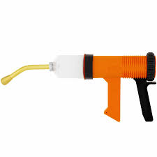

- Which of the following is not a human intestinal worm? Earthworms
- The human intestinal worm drawn below is a tapeworm
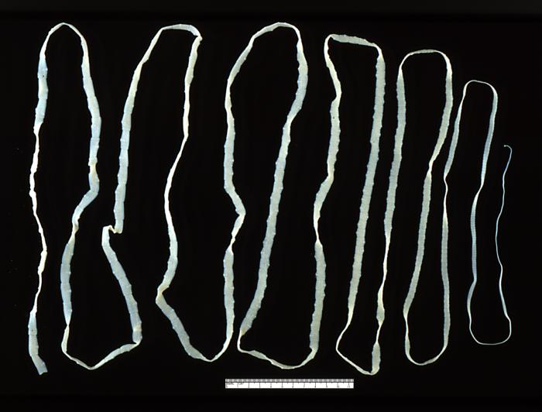
- The process of administering liquid medicine to animals is known as drenching
- Structures constructed for the purpose of restricting the movement of animals during spraying are known as crushes.

CORRECTION

6. I destroy the quality of wool in sheep. Who am I? Mite

